Lab Manual



SUPERIOR UNIVERSITY LAHORE PAKISTAN

LAB -04

Task 1

Design the network of "Lab-7" or “Lab-8” (2-3 rows of computers) Use: Server, Switch, Router, & End-Devices like Laptop/PC Assign them IP Address (Dynamically/DHCP) of any Network (or you can use network 192.168.1.0)

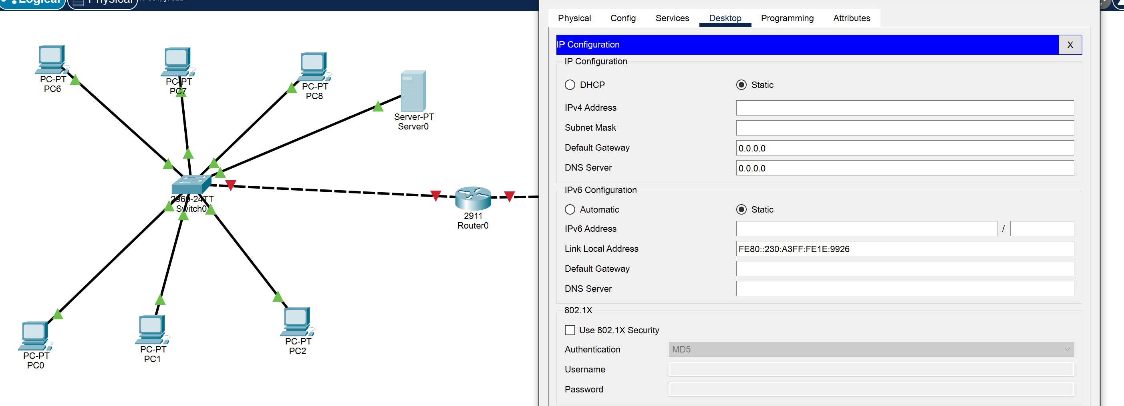

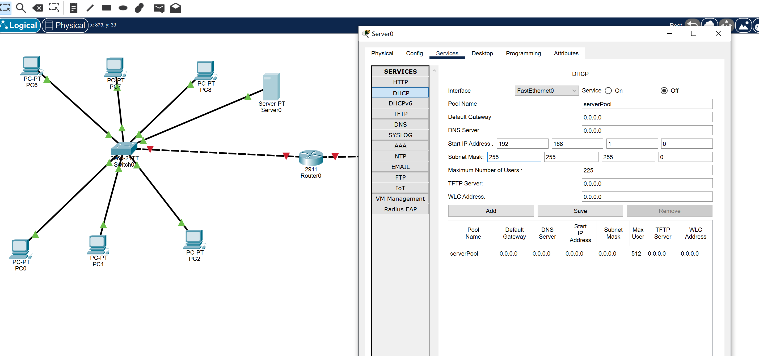 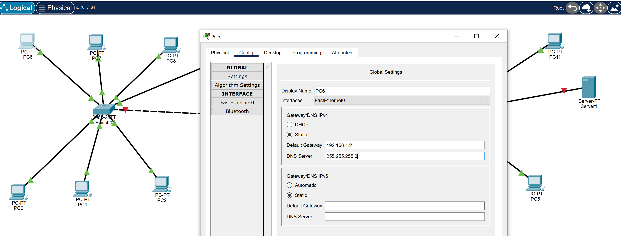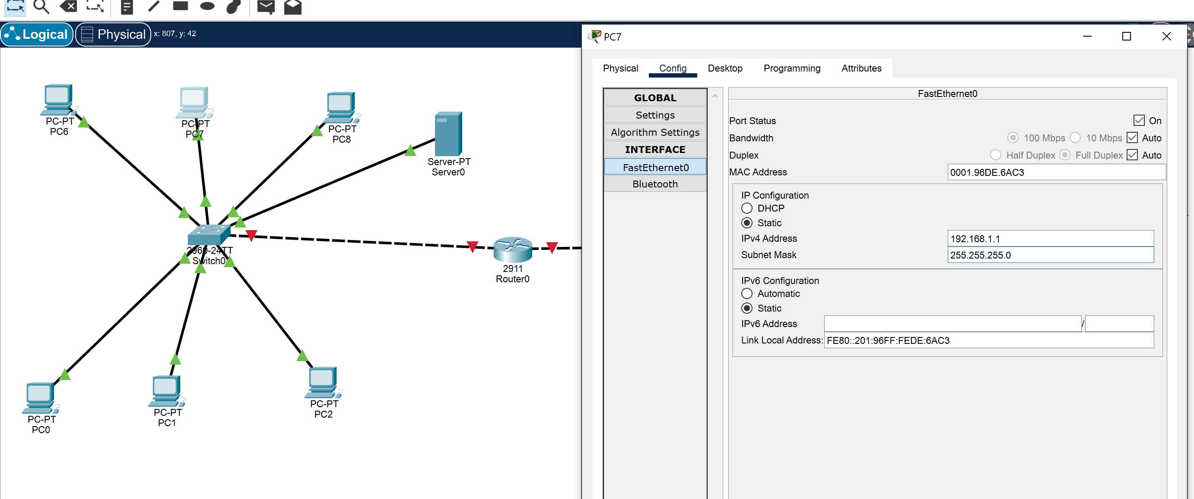

4